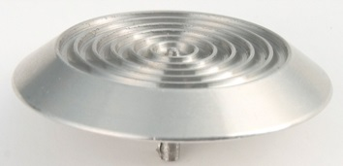 | 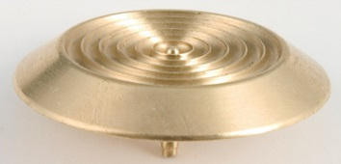 | 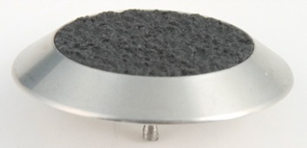
2810 Stainless Steel  Grooved with stud | 2870 Brass Grooved  with stud | 2814 Stainless Steel with Non-slip Insert  2815 Without stud
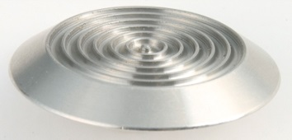 | 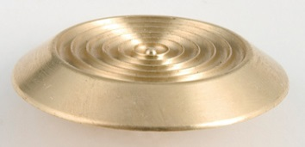 | 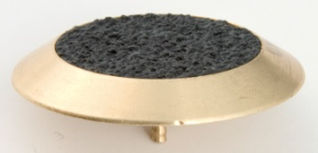
2811 Stainless Steel  Grooved without stud | 2871 Brass Grooved  withou stud | 2874 Brass with  Non-slip Insert  2875 Without stud
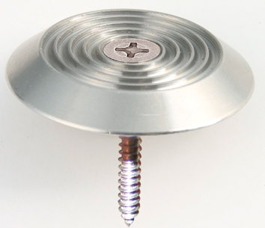 | 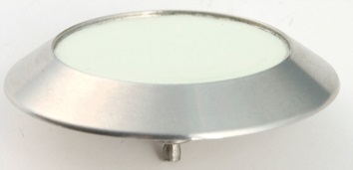 | 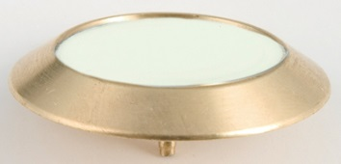
 | 2816 Stainless Steel with  Luminescent Insert  2817 Without stud | 2876 Brass with  Luminescent Insert  2877 Without stud
2812 Stainless Steel
with screw

